VBS/Day Camp idea
God created and loves the whole world: Revelation 7:9 – “After this I looked and there before me was a great multitude that no one could count, from every nation, tribe, people and language, standing before the throne and in front of the Lamb. They were wearing white robes and were holding palm branches in their hands.”
Childhood is a great time to start learning about and caring for the world God created. That’s why many VBS Curricula already include a missions component. Here is a simple way to incorporate this into your already existing VBS or Day Camp. If you add a fundraising aspect to this, you can include the funds in your World Services giving.
Celebrate India with your 5 senses (Can be used one per day, or all in one day)
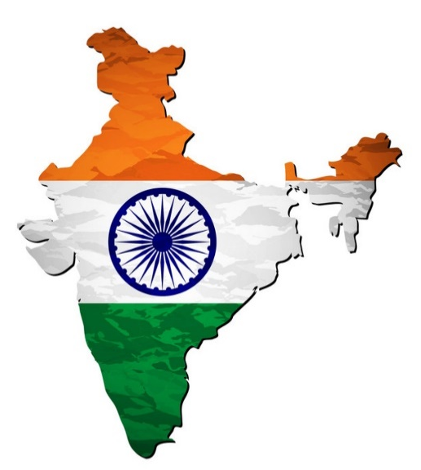
(Snack time) (Recreation)(Craft idea)
Taste
Easy, kid-friendly, affordable options:
-Coconut water
-Chai tea
-Naan
-Ripe Mango
-Bananas

See
-pictures
-colorful fabrics
-children’s storybooks from/about India (check your local library for options!)

Smell
-Spices: curry, Garam Masala, turmeric, cumin, coriander, ginger
-chai tea
-lotus (The national flower of India is the lotus. Find lotus scented essential oils to permeate the room)

Feel
-sari fabric
-hot weather
-barefoot walking and playing (be sure the area is safe!)

Hear
-Indian music
-Dandiya stick dance Check Youtube for “easy” or “simple” instructions. An example is this one which shows men and women dancing (so it doesn’t seem like just a “girly” activity.) https://www.youtube.com/watch?v=7ewpNQ6rZ0Y It is a bilingual video so don’t be concerned that you and the kids won’t understand.
-Have kids make their own Dandiya dance stick (either buy 5/8 or ¾ in. dowel rods and cut in 12 in. lengths, or follow this youtube video on making them with newspaper, then decorate with whatever supplies you want: paint, washi tape, ribbon, yarn, etc.) https://www.youtube.com/watch?v=1yrbTQCJOXE

