World Missions Spirit Week |  | 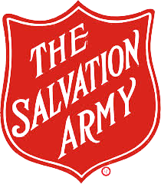  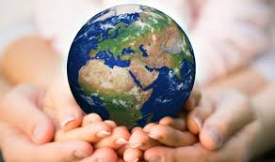

MONDAY – Camp
World Services donations have supported the India South Western Territory’s Christian Education Camp for 360 children, ages 7-14. The children learned about Biblical heroes, enjoyed crafts and games, fellowshipped together, and were spiritually renewed with 275 of the children dedicating their lives to Christ. Wear your favorite camp shirt and give 5¢ for each t-shirt you own to support camps like this around the world.
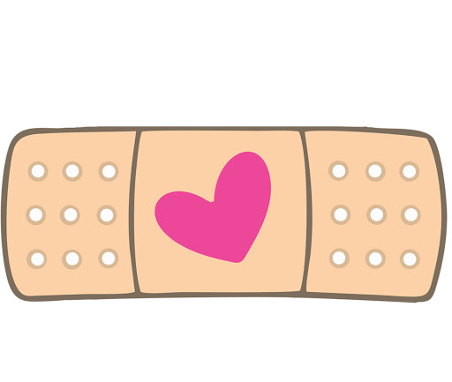 | TUESDAY – health care  The Onamuga Health Centre, located in rural Papua New Guinea, offers the only local access to health services for the 50,000 residents of that area. A medical situation may require a 2 hour drive on a very rough road to the closest hospital. World Services funds allowed the purchase of a fully equipped ambulance, allowing safer transport and enabling medical staff to better care for patients. Dress as a health care worker and pay 1¢ for every band-aid in your house.

WEDNESDAY – School Libraries

The Salvation Army in Guatemala runs six schools. The teachers wanted to have school libraries since the children don't have access to books at home nor have local public libraries. US Salvation Army fundraisers have provided money to fill these school libraries with books for the children to enjoy, growing their imaginations and reading skills. Dress as your favorite fictional character and pay 1¢ for each book you own.
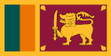 | THURSDAY – Farming  In Sri Lanka, The Salvation Army has a farm that grows many trees and sells the products to raise money to help their communities with feeding programs, children’s homes etc. One of the things they grow and sell is cinnamon. I like to put cinnamon in my tea and in ice cream. What do you use cinnamon for? See what else you can learn from the video this morning. Count your spice jars and pay 10¢ for each one. Wear the colors of the Sri Lankan flag today.
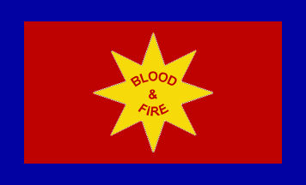 | FRIDAY – around the world  Do you know how many countries The Salvation Army serves?? 131!! That’s the majority of countries in the world where we are telling people about Jesus; helping give food, shelter and healthcare; providing disaster relief, rehabilitation and more. Wear something that represents another country and pay 25¢ for each country you or someone in your family has visited.
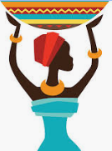 | SATURDAY - artisans  The Salvation Army OTHERS program helps empower artisans through global business. Producers in Kenya, Bangladesh, Pakistan and Moldova learn a trade like sewing, metal work, or wood work and earn a fair wage for their products which are then sold in the USA, Canada, Switzerland, and Norway. The OTHERS program helps to bring dignity, independence and hope to these artisans. Pay 10¢ for the art on your walls, maybe make something special today and wear a tie dye shirt.
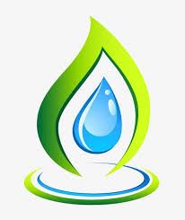 | SUNDAY – CARE FOR THE ENVIRONMENT  Some projects funded by World Services help ensure that Salvation Army facilities have access to resources. In Kenya, India, and other places around the world, many water tanks and towers are installed on Salvation Army property, providing individuals with easier access to safe, clean water!  In Sri Lanka solar panels were installed at a few Salvation Army centers to ensure reliable access to electricity. These projects help reduce utility bills and provide sustainable resources. Have members of your family wear the colors of the Earth (green for land, blue for water and someone in yellow for the sun!) and pay 10¢ for every outlet and light switch in your house.

